1.INTRODUCTION

1.1 Overview

Zoho books is an online accounting application that takes care of the accounting needs to be your business.

1.2 Purpose

Travel takes us out of our comfort zones and inspires us to see.

2.Problem Definition & Design Thinking

2.1 empathy map

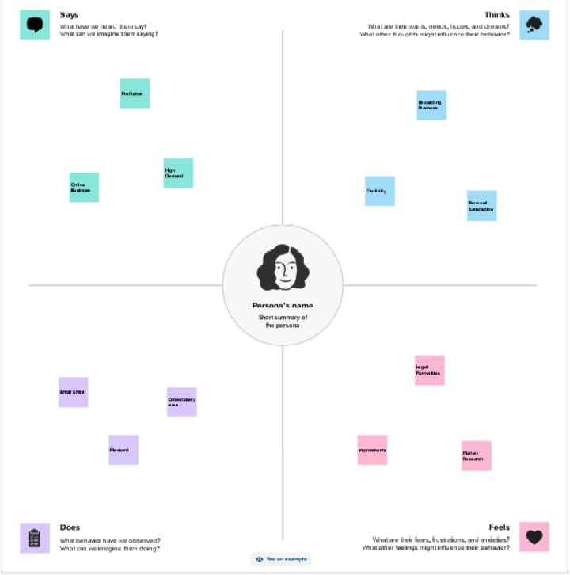

2.2 Brainstorming map

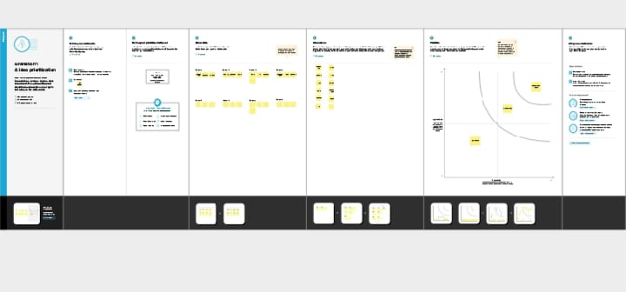

3.Result

A.profit&loss

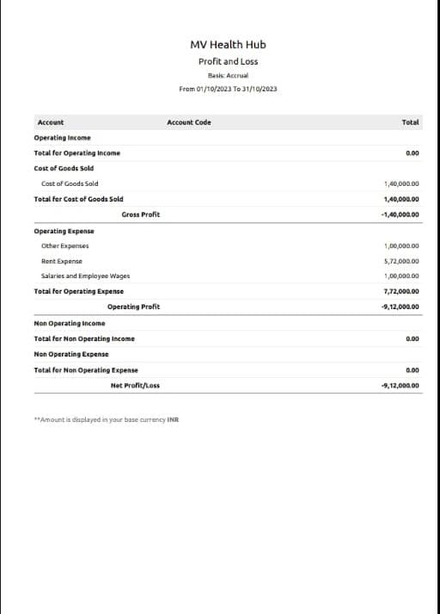

B.Balance sheet

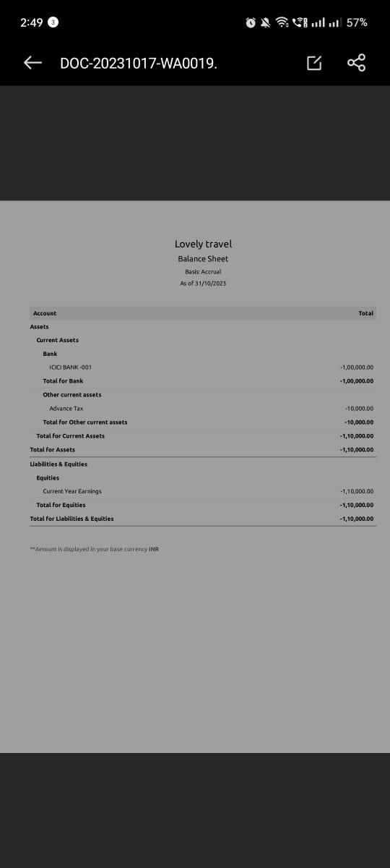

4.Advantages & Disadvantages

ADVANTAGES

1.Enjoy a perfect balance of touring and free time.

2.Make friends for life.

3. Exceptional value for money.

4. Curated experiences just for you.

DISADVATAGES

1.Enough time to explore.

2.experience the places you visit.

3.Group of strangers.

4.which can limit your privacy and independence.

5.APPLICATION

1.Keerthi grabbed his hand and virtually dragged him to her liabrary.

2.sweets-kaju katli,basandhi and dry fruit halwa.

6.CONCLUSION

This is a book to be read slowly for its savor.

7.FUTURE SCOPE

Horticultural crops are important for human Nutrition.